**Assignment -1**

<!DOCTYPE html>

<html>

<head>

<title> Registration Form</title>

</head>

<Body styles="text=align:center:">

<h3>Registration Here</h3>

<form actions="/action_page.php" id="users" action="#"method="POST" target="_blank">

UserName:<input type="type"text" name="Name" placeholder="Enter your Name">

<br><br>

Email:<input type="email" name="Email_id"placeholder="Enter Email_id">

<br><br>

Phone Number:<input type"number" placeholder="Enter Phone Number">

<br><br>

<input type="submit" value="REGISTER">

</form>

</body>

</html>

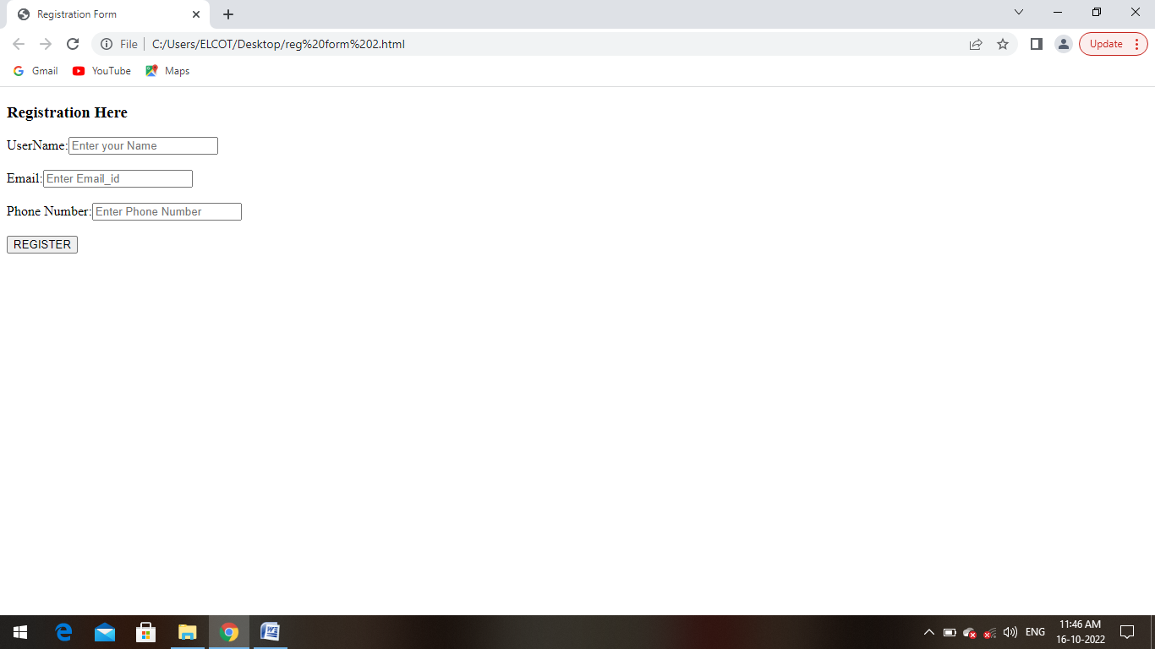

2 .Develop a flask program which should contain atleast 5 packages used from pypi.org.

from flask import Flask,redirect,url_for,render_template,request

app=Flask(__name__)

@app.route('/success/<name>')

def success(name):

return "welcome %s" %name

@app.route('/login',methods=["POST","GET"])

def login():

if request.method=="POST":

user=request.form["nm"]

return redirect(url_for('success',name=user))

if __name__=='__main__':

app.run(debug=True)